**NAME: MUHAMMAD SHOAIB AKHTER QADRI**

**CLASS: BSE (3B)**

**ENROLLMENT NO: 02-131212-009**

**REG NO: 79290**

**ASSIGNMENT NO: 02**

**TRIP REPORT**

**Date:** 08/November/2022

**Day:** Tuesday

## Proceedings of the day in a chronological order:

1. First we visited **Quaid-e-Azam House** also known as **Flagstaff House** .
2. Secondly we visited **Shipyard** where we visited Auditorium, seen ships repairing/building .
3. Then we gone toward **BurnsRoad** where we also have some lunch.
4. At last we visited **State Bank Museum.**

## Connection of each site to its historical/ monumental worth:

**Quaid-e-Azam House**

In 1984, it was converted into the Flagstaff House Museum of Jinnah. The Quaid-e-Azam House, also known as Flagstaff House, is a house museum dedicated to the personal life of Muhammad Ali Jinnah, the founder of Pakistan. Located in Karachi, Sindh, Pakistan, it was designed by British architect Moses Somake. The is the former residence of Jinnah, who lived there from 1944 until his death in 1948. His sister, Fatima Jinnah lived there until 1964. It was bought by Jinnah in 1943 at the cost of 150,000 Pakistani Rupees . The building was later acquired in 1985 by the Pakistani government and converted to a museum.

**Address:** V22M+G35, Fatima Jinnah Rd, Karachi Cantonment, Karachi, Karachi City, Sindh

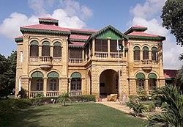

# Karachi Shipyard & Engineering Works

It was established in the mid fifties as a project of Pakistan Industrial Development Corporation (PIDC) and was later incorporated as a public limited company in 1957 which is managed by a Board of Directors and a Managing Director. The shipyard is spread across 71 acres and located at West Wharf in Karachi. It is equipped with a large shipbuilding hall, three block fabrication areas, three shipbuilding berths, two dry docks, a machine shop, a grit blasting and painting facility, a 7881 tons capacity ship lift and transfer system, 13 parking stations. The Karachi Shipyard & Engineering Works Limited (KS&EW) is a Pakistani state- owned defense contractor and military corporation situated in the West Wharf in Karachi, Sindh in Pakistan.

The KSEW Ltd. is the oldest and the only shipyard in Pakistan, catering for shipbuilding, ship repair and general heavy engineering. It has built numerous cargo ships, oil tankers, tugboats and support vessels, landing craft, naval vessels and submarines for the Pakistani Navy. It also builds and repairs for Pakistan National Shipping Corporation, Karachi Port Trust, Port Qasim Authority and for a wide range of customers in the private sector in Pakistan. Company's entire shares are owned by the Government of Pakistan under the administrative control of Ministry of Defence. The current Managing Director of KS&EW is Rear Admiral Ather Saleem. Karachi Shipyard & Engineering Works acquired certification of ISO 9001 in 2000.

**Address:** RXQG+R5V، Dockyard Road, West Wharf Karachi, Karachi City, Sindh

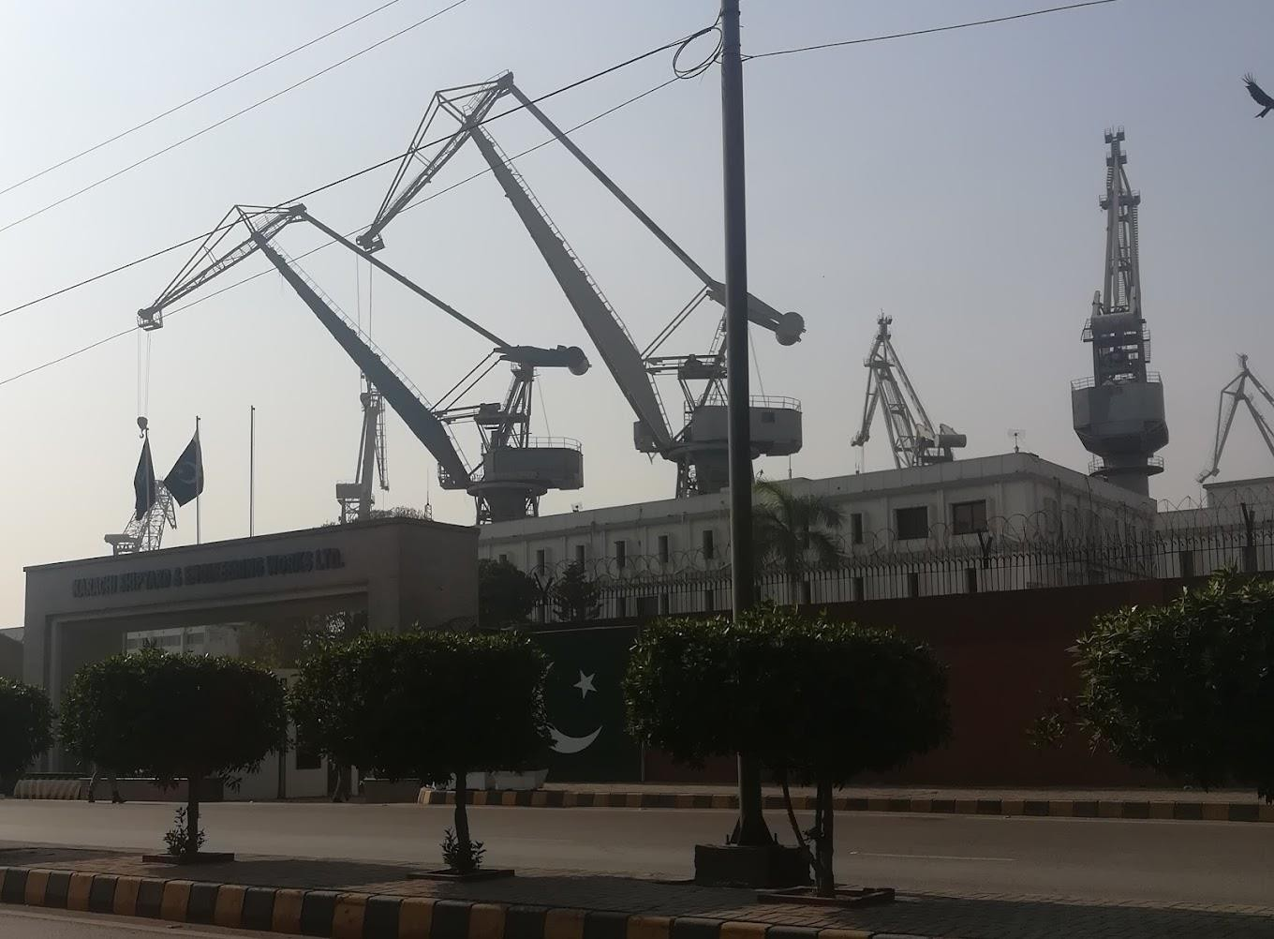

# Burns Road

Burns Road (also spelled Burnes Road, and formally known as Muhammad Bin Qasim Road) is a street located in Karachi, Pakistan. It is well-known in the city for its many restaurants and street food vendors. Burns Road was named after the Scottish doctor and spy, James Burnes, who worked in British India in 19th century. After the foundation of Pakistan, the name of street was officially changed to Muhammad Bin Qasim Road, after Arab military commander Muhammad bin Qasim. The street has restaurants that were founded in the 1940s.

The street is considered a melting pot and is home to people of different ethnicities, including Punjabi Saudagaran-e-Delhi, Memons, Gaddis, and Qureshi Baradri.

**Address:** Burns Road, M.A Jinnah Road

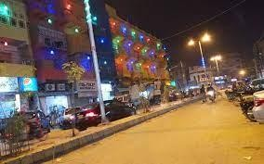

# State Bank Museum

State Bank of Pakistan Museum & Art Gallery is a museum on Ibrahim Ismail Chundrigar Road in Karachi, established in 2004 to introduce the **first Monetary Museum** of Pakistan. The current State Bank of Pakistan Museum & Art Gallery building, previously the Imperial Bank of India, is a Greco Roman building in Jodhpuri Red Sandstone constructed in the 1920s by the British government. In 2004, the State Bank of Pakistan decided to adapt the building as a museum; work on the projects started in 2006 and was devoted to conservation of the building and acquisition of the collection.

## Coins Gallery

The Coins Gallery displays the techniques with some original dies of coin making in Pakistan Mint, also include some old machines, the process of coin making along some tools, and a documentary covering the whole process of coin minting in Pakistan Mint. The Coin Gallery is divided into two parts, Pre Islamic Gallery and Islamic Gallery till to the Present-Day period Coinage.

The Pre Islamic Gallery exhibition starting from barter system, seals used as coins by Indus valley people, punch-marked coins dated from 6th century B.C. The pre Islamic Gallery also displays some uncommon bar copper and silver coins, Indo Greeks including an uncommon bronze coin of Alexander the Great and several other unique coins, Indo Scythians, Indo Parthian, Kushans, Guptas, Indo Sassanians, Hindu Shahis. The Islamic Gallery exhibition starts from the coinage of Arab Governors of Sindh, some uncommon Sultanate coins, Mughal coins, later Mughals, British Indian, and then coinage after 1947.

## Currency Gallery

The Currency Gallery gives an overview of the origin of paper currency in the sub-continent, from early paper issues to polymer banknotes. The gallery of the museum displaying the history of Currency Notes in Pakistan and also includes the collection of historical, current and polymer banknotes of different countries around the world. The Currency Gallery includes the complete collection of Pakistani banknotes since its origination (1947–present).

**Address:** RXXX+9QF, I.I Chundrigar Rd, Lalazar, Karachi, Karachi City, Sindh

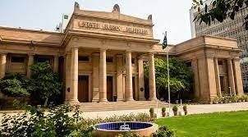

# Lessons Learned

1. I have learned many different traditions that were followed in old times and the type of currency the different sects of people used. I have also seen different types of currency used in now a days in different countries from state bank museum.
2. From the shipyard I have learned that how the new ships are build and the repairing of ships they also showed us a detailed report on different things done in shipyard and about the new ship built in Pakistan called **HAIBAT.**
3. From the Quid-e-Azam House I have learned about how our leader used to live, about what type furniture he used The Shoes he used to wear.